**Festive Season Grocery Packs Project**

The Corporation in partnership with the Eastern Cape Department of Safety and Liaison hosted the “Christmas Grocery Packs Project”, CSR Project in Willowvale Community, Mbashe on 21st December 2015. The programme benefitted the families which were affected by the road fatalities in the area during the weekend of 29 August 2015. A Total of one hundred (100) households benefitted in this initiative both in Willowvale and Queenstown.

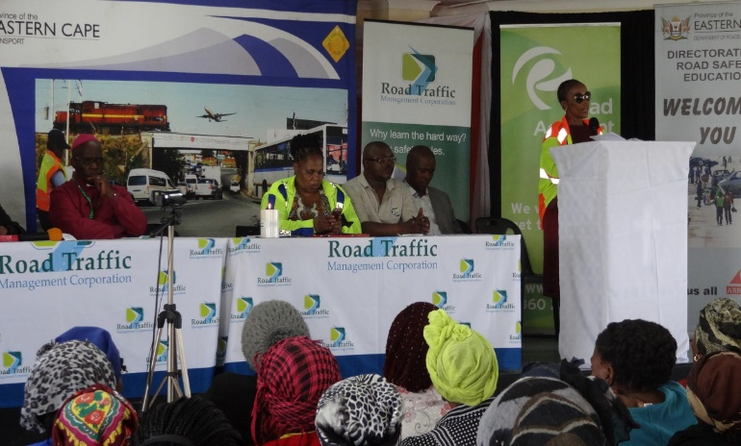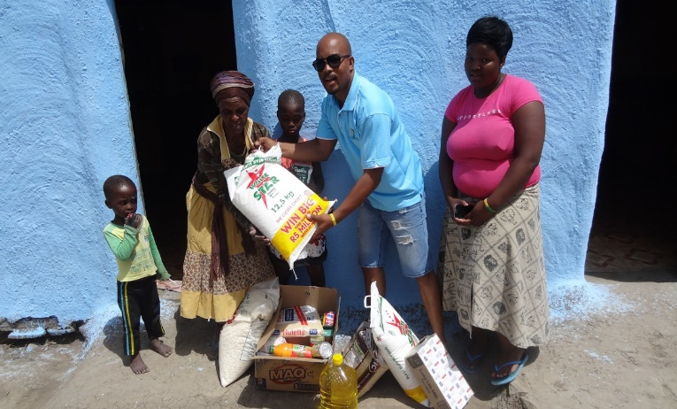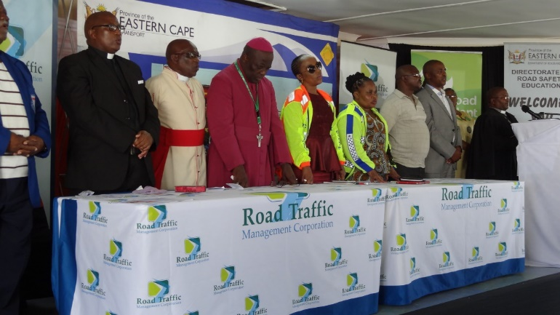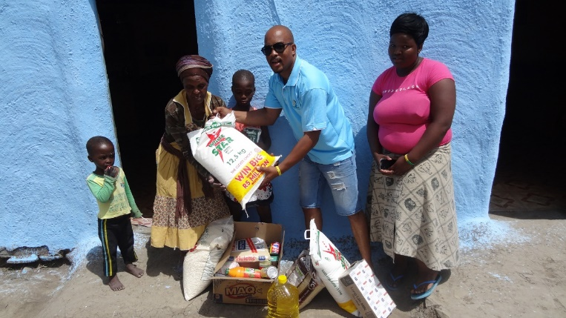

**Child Headed Households Educare Project**

Furthermore, the Corporation in partnership with Department of Transport hosted a Child Headed Households Educare Project in Mpumalanga, Volksrust.Focused on (one hundred) 100 vulnerable Child Headed Households in the area, of which the breadwinners and/or parents were victims of road fatalities. Assisted with grocery packs and school shoes to the vulnerable child headed households in the community.

